**Hannah Green**

**E21**

**A & D - Analysis and Design Unit**

**A.D 1 A Use Case Diagram**

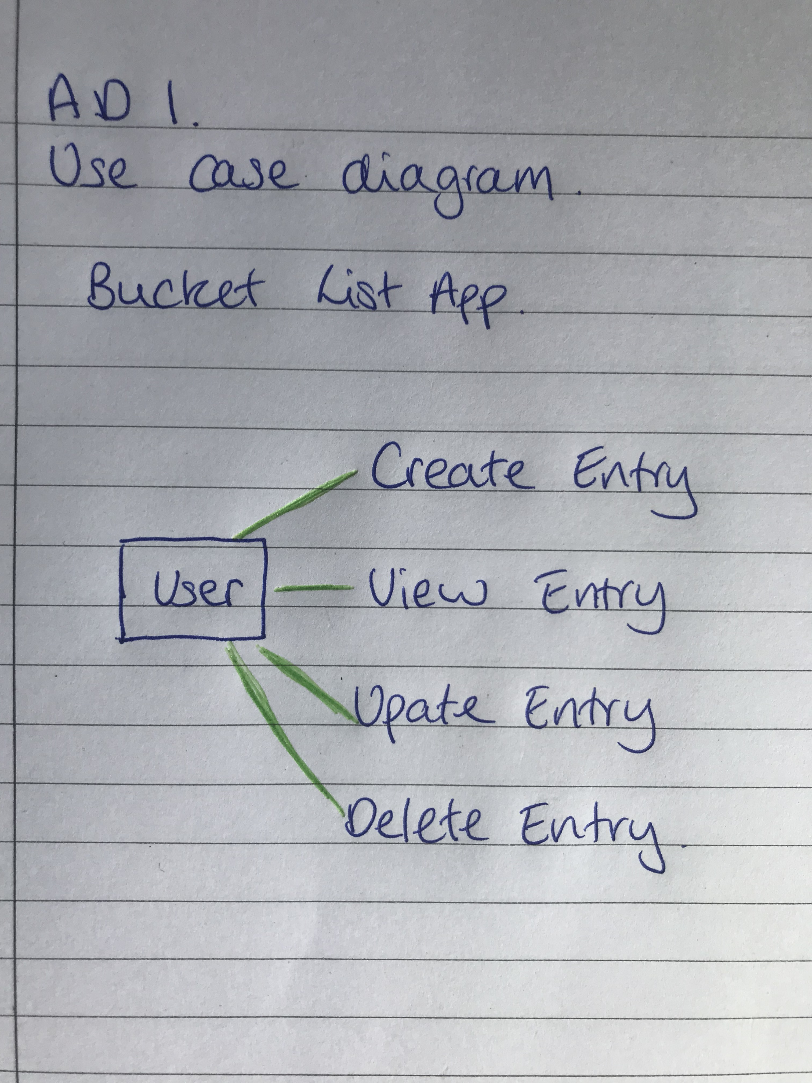

**A.D 2 A Class diagram.**

**A.D 3 An Object diagram.**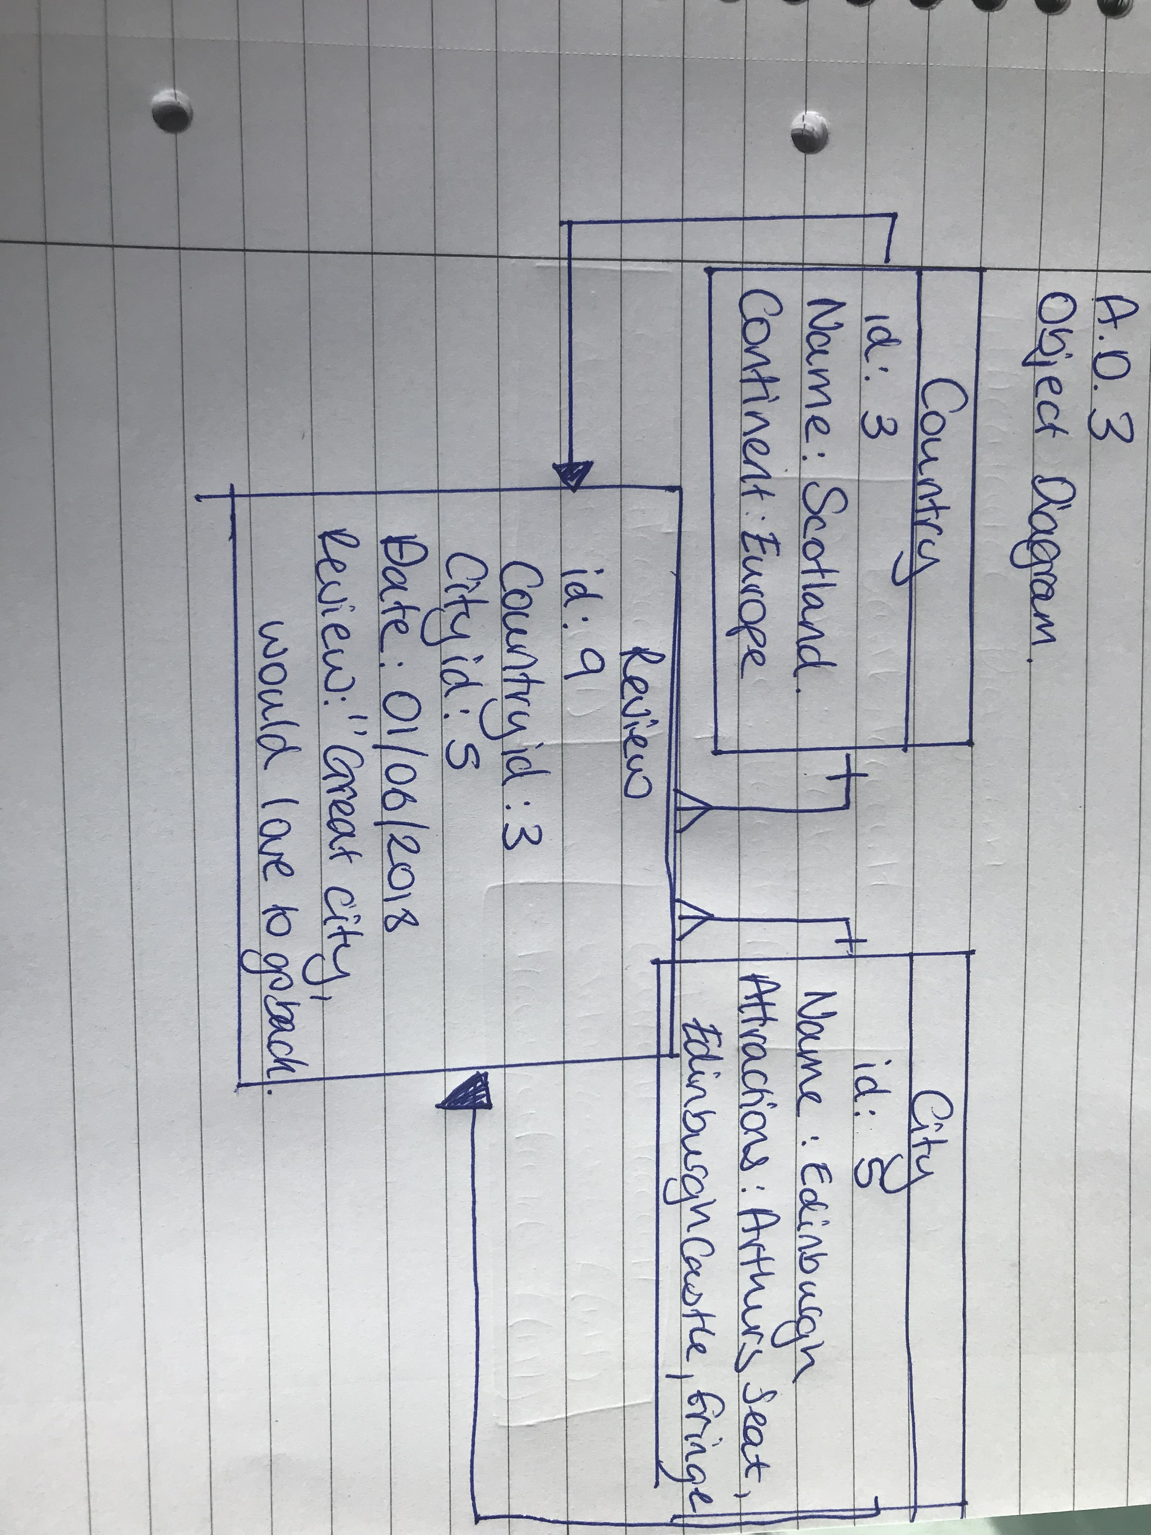

**A.D 4 An Activity Diagram**

**A.D 5 An Inheritance Diagram**

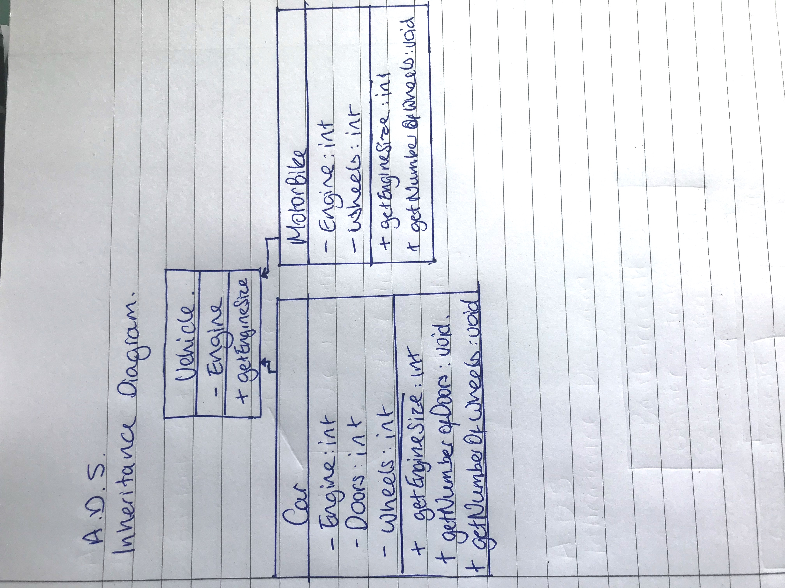

**A.D 6 Produce an Implementations Constraints plan detailing the following factors:**

*● Hardware and software platforms*

*● Performance requirements*

*● Persistent storage and transactions*

*● Usability*

*● Budgets*

*● Time*